Nalongsone Danddank Student ID : 14958950 StarID: jf3893pd

Email: [nalongsone.danddank@my.metrostate.edu](mailto:nalongsone.danddank@my.metrostate.edu)\

**ICS 365. Organization of Programming Languages.**

**Programming Assignment 1.**

**Part 2: Create a Hello World Project**

1. **Review Appendix A or Appendix B**
2. **Create a file with the following content:**

**(remember you might want getchar(); as the last line of the file if you are using windows)**

**#include <stdio.h>**

**int main(int argc, char *argv[])**

**{**

**printf(“Hello world \n”);**

**}**

**Answer:**

**Code:**

**#include <stdio.h>**

**int main(int argc, char *argv[]) {**

**printf("Hello World\n");**

**return 0;**

**}**

1. **Compile and run. What is the output?**

**Answer output screen: “Hello World” with return value 0.**

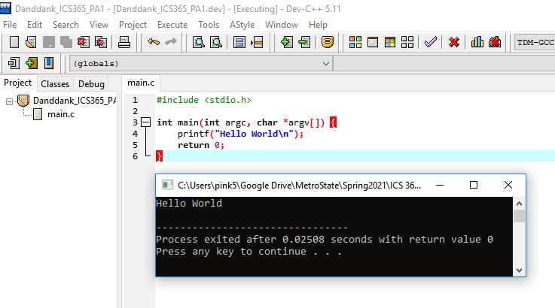

1. **Modify the program as below:**

**#include <stdio.h>**

**int main(int argc, char *argv[])**

**{**

**printf(“Hello world \n”);**

**printf(“%s \n”, argv[0]);**

**printf(“%s \n”, argv[1]);**

**}**

**What is displayed? (There should be 3 lines)**

**Answer:**

**#include <stdio.h>**

**int main(int argc, char *argv[]) {**

**printf("Hello World\n");**

**printf("%s\n", argv[0]);**

**printf("%s\n",argv[1]);**

**}**

**Screen output: The first line is “Hello world” and second line is the file location, the last line is bank. Then auto return value 4294047295.**

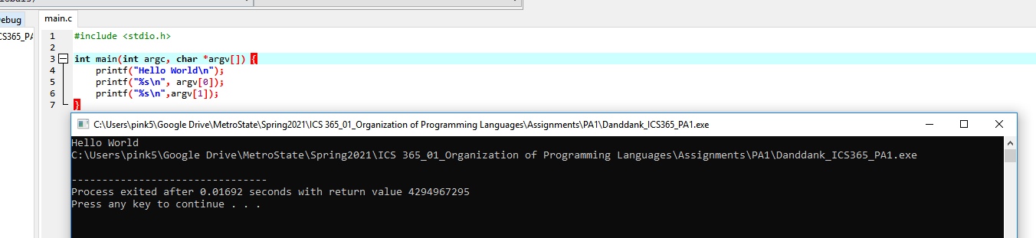

1. **Modify the program as follows:**

**#include <stdio.h>**

**int main()**

**{**

**char a = 30;**

**char b = 40;**

**char c = 10;**

**char d = (a * b) / c;**

**printf ("%d ", d);**

**return 0;**

**}**

**What is the output?**

**Answer: print out the value of d that is the result of (a*b)/c = 120, with return value 0.**

**#include <stdio.h>**

**int main() {**

**char a = 30;**

**char b = 40;**

**char c = 10;**

**char d = (a * b) / c;**

**printf("%d ", d);**

**return 0;**

**}**

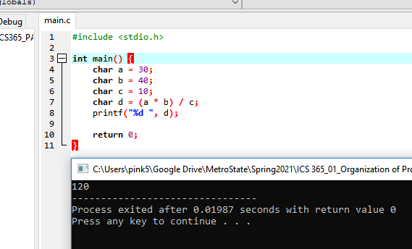

1. **Modify your source file as follows:**
2. #include <stdio.h>
3. void fun(int*, int*);
4. int main()
5. {
6. int i=5, j=2;
7. fun(&i, &j);
8. printf("%d, %d \n", i, j);
9. return 0;
10. }
11. void fun(int *i, int *j)
12. {
13. *i = *i**i;
14. *j = *j**j;
15. }

**What is the output?**

**Answer:**

**#include <stdio.h>**

**void fun(int*, int*);**

**int main() {**

**int i=5, j=2;**

**fun(&i, &j);**

**printf("%d, %d\n", i, j);**

**return 0;**

**}**

**void fun(int *i, int *j){**

**\*i = *i**i;**

**\*j = *j**j;**

**}**

**Screen output: print out the result of calculation of function fun() that take a pointer or reference of i and j, then print them out the result 25, 4.**

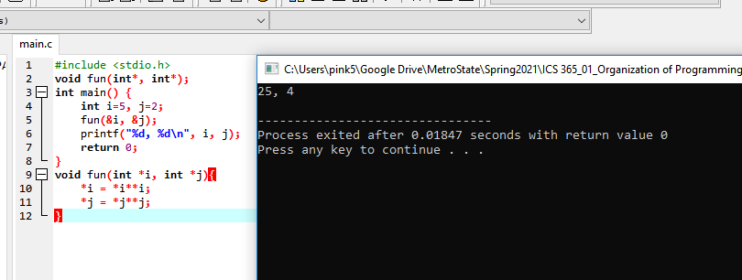

**Using a your debugging, set breakpoint at line 6.**

**Modify the value ‘i’ to be 6.**

**Answer:**

**Code:**

**#include <stdio.h>**

**void fun(int*, int*);**

**int main()**

**{**

**int i=6, j=2;**

**fun(&i, &j);**

**printf("%d, %d\n", i, j);**

**return 0;**

**}**

**void fun(int *i, int *j){**

**\*i = *i**i;**

**\*j = *j**j;**

**}**

**What is the output?**

**Screen output: After modify the value ‘i’ to be 6 and set breakpoint at line 6 or on the “fun(&i, &j);” then the complied result is empty because the program was broken on we set breakpoint that mean the function “fun()” not take processing yet and the “printf()” function will not print anything to screen.**

